GENETICS: BIOLOGY HSA REVIEW

- Matching: On the lines provided, write the letter of the definition of each term.

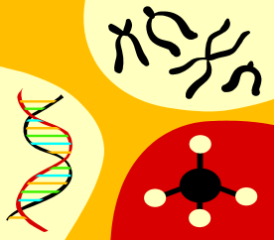
- genetics f. gamete
- trait g. probability
- hybrid h. Punnett square
- gene i. haploid
- allele j. meiosis

g 1. likelihood that something will happen
____ j___ _2. process of reduction division
____ b ___ 3. specific characteristic
____ c_____4. offspring of crosses between parents with different traits
___ _i _____5. containing a single set of chromosomes
____ f___ __6. sex cell
___ _d_____7. factor that determines traits
____ h_____8. diagram showing possible gene combination
___ _a_____9. the scientific study of heredity
___ _e_____10. form of a gene

- Punnett Squares: On the lines provided, answer the following questions about
Punnett squares.

- How do geneticists use Punnett squares? Scientists can study the possible genotypes and phenotypes of offspring.

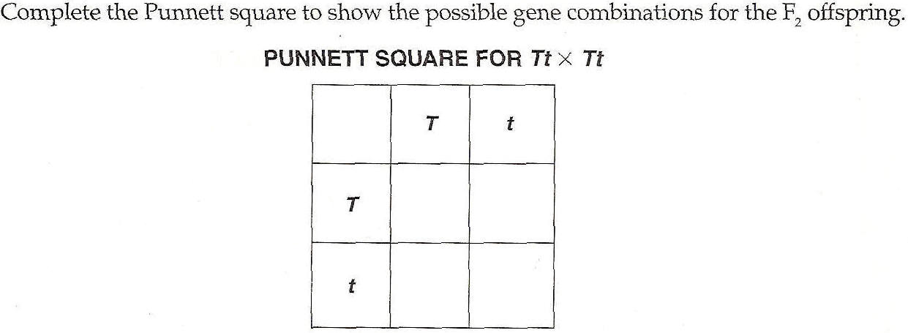
TT
Tt
Tt
tt
- Reading Passage: Use the information below to answer Numbers 1 through 3.
WHERE DID THE DOG COME FROM?
The canine group began evolving about 30 million years ago from a tiny tree climbing animal, Miacis. The dog appears to be the first animal domesticated by humans. DNA evidence indicates that dogs were initially domesticated from wolves about 100,000 years ago. Tribes used dogs for help with hunting, for protection at night, and for companionship.

After dogs were domesticated, they were selectively bred for particular characteristics. Just as other domesticated animals have been bred, dogs were bred so that they had the characteristics most desired by humans. In different parts of the world, the choice of desirable characteristics varied, resulting in the diversity we see today.

As dogs continued to live as human companions, many new breeds were developed for specific tasks, such as hunting, guarding, working, and companionship.

The basic principles of dog breeding are those that apply to any animal. Breeding pairs are selected for the desirable genes they will pass on. Some characteristics involve single-gene inheritance. A cross between two heterozygous parents can produce a puppy with brown eyes even though both parents have blue eyes. NOTE: In German Shepherds, the allele for brown eyes is recessive.

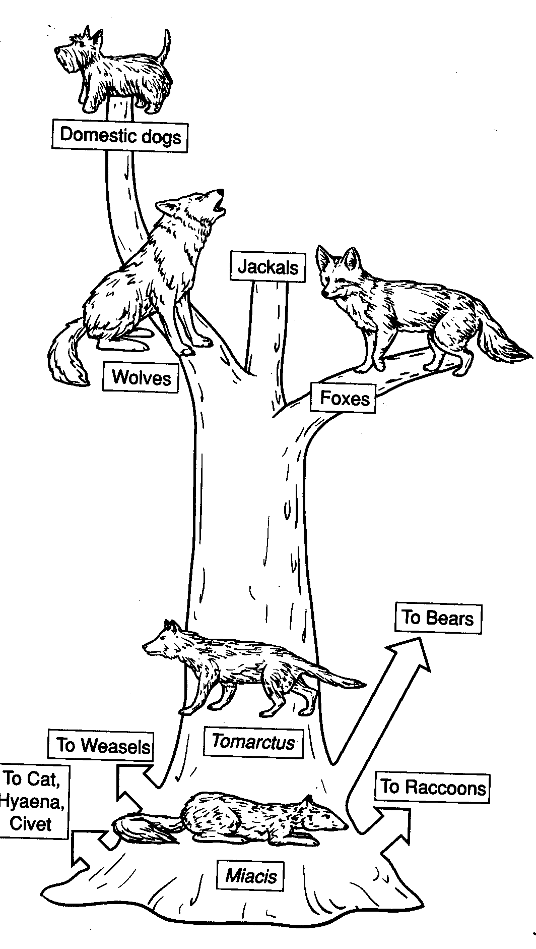

b 1. If a homozygous German Shepherd with brown eyes is bred with a heterozygous
German Shepherd with blue eyes, is it possible to have puppies with brown eyes?
  - Yes, and all potential offspring will be carriers of the allele for blue eyes.
  - Yes; 50% of the offspring would be heterozygous for blue eyes, and 50% of the offspring would have brown eyes.
  - Yes; 25% of the offspring will have brown eyes.
  - No; none of the offspring will have brown eyes.

c 2. Based on the information above, dogs were the first animals to be domesticated by humans. Scientists most likely domesticated dogs by
- cloning a member of a population of genetically identical cells taken from wolves
- inducing mutations to increase the genetic variation in the population
- selectively breeding the dogs in order to pass on the desired traits to the next generation of offspring.
- inbreeding the dogs to maintain the desired or similar characteristics

- True/False: Indicate if the statement is true or false. If true, mark T. If false, change the word or phrase to make the statement true.

__ Two _1. The replication of a DNA molecule results in four copies of the same gene.
___RNA__2. If a nucleic acid contains uracil, it is DNA.
____T____3. During DNA sequencing, if all the bands on an electrophoresis gel are the same color, the single-stranded DNA sample consisted of one kind of fragment.
Nucleotide 4. Exposing a population of plants to radiation or certain chemicals can increase the frequency of mutations that occurs within the population.
Always 5. An organism with a dominant allele for a particular form of a trait will sometimes exhibit that trait.
____T____6. Blood type in humans is determined by a single gene that has multiple alleles.

E. Compare/Contrast Table: Complete the table below using information from the textbook.
 | Mitosis | Meiosis
Function | Growth; generation of new cells; repair of tissues | Production of gametes for sexual reproduction
Location in Body | All body cells | Only in certain cells of the reproductive system (ovaries in females; testes in males)
Number of Daughter Cells | Two | Four
Number of Phases | Four | 8 – 4 in Meiosis I, and 4 in Meiosis II
Change in Chromosome Number in Parent & Daughter Cell | None – each daughter cell has an identical set of chromosomes. | Diploid to haploid; four haploid daughter cells are formed.
Number of Cell Divisions | One | Two
Difference in DNA  Between Parent Cell and Daughter Cells | None – daughter cells have DNA that is identical to the parent cell | Homologous chromosomes assort independently, so each gamete has a unique combination of alleles

F. Mendelian Genetics: On the lines provided, complete the following sentences, by using the word bank below.
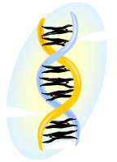
dominant homozygous
recessive heterozygous
genotype Punnett square
phenotype probability

Alleles are matching genes that control contrasting characteristics of a trait, such as dark or light hair color. If two similar alleles for a characteristic are present, the offspring exhibits that characteristic. What happens when the offspring receives two different alleles? When this happens, the (1) dominant allele is expressed. The other characteristic, the (2) recessive allele, is not expressed. Recessive alleles are expressed only when no dominant alleles are present. An organism that has two dominant or two recessive alleles for a trait is said be (3) homozygous. An organism is called (4) heterozygous if it has one dominant and one recessive allele for a trait. The alleles that an organism inherits from its parent make up the organism’s (5) genotype. The form of the trait the organism displays is its (6) phenotype.

G. Matching: Match the labels to the parts of the pedigree chart shown below. some of the pedigree may be used more than once.

__a__ 1. a person who expresses the traits __b__ 4. represents a marriage
__c__ 2. a male __a__ 5. a female
__c__ 3. a person who does not express the trait __d__ 6. connects parents to their children
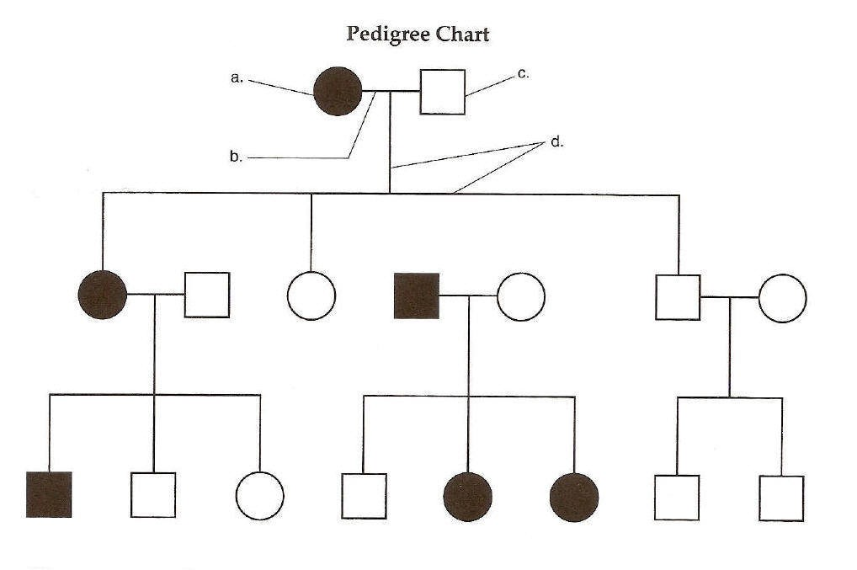
PEDIGREE

H. BCR
Hemoglobin, a protein found in red blood cells, carries oxygen. Abnormal hemoglobin cannot carry as much oxygen as normal hemoglobin. The sequences below show sections of the DNA sequence that produce both the normal and abnormal types of hemoglobin.
SECTION OF GENE FOR HEMOGLOBIN

Normal DNA sequences: GGA CTC CTC
Abnormal DNA sequences: GGA CAC CTC

MESSENGER RNA CODON TABLE

Codon | Amino Acid
GUG | Valine
CAC | Histidine
CUC | Leucine
ACU | Threonine
CCU | Proline
GAG | Glutamic acid

- Write the messenger RNA sequences that will be produced from the normal and abnormal DNA sequences shown above.
- Using the Messenger RNA Codon Table, write the amino acid sequences assembled from the DNA for normal and abnormal hemoglobin.
- Beginning with DNA, describe the process that forms proteins such as hemoglobin.
Write your answer on a separate sheet of paper.

The HSA Science Rubric should be used to score student responses. Answers should include the following information:
- Messenger RNA sequences that would produce normal hemoglobin:
CCU GUG CUC
Messenger RNA sequence for abnormal hemoglobin production:
CCU GUG GUG

- Amino acids assembled from the DNA for normal hemoglobin:
proline, glutamic acid, and glutamic acid
Amino acids assembled from the DNA abnormal hemoglobin:
proline, valine, and glutamic acid

- Student responses should include an understanding of transcription and translation and should use appropriate scientific vocabulary to describe the processes. The following is a sample student response. Transcription is the process by which genetic information encoded in DNA is transferred to an RNA molecule. Genetic information must be copied because DNA cannot leave the nucleus. Instead of sending out DNA, copies of genes are sent into the cell to direct the assembly of proteins. These working copies are messenger-RNA molecules made from a DNA template. Transcription requires the help of enzymes. RNA polymerase, unwinds the double stranded DNA. As it moves along the DNA strand, complementary base pairing takes place, and a messenger-RNA molecule (m-RNA) is produced. m-RNA is similar to DNA but is shorter than DNA (because it corresponds to one gene rather than a whole strand or chromosome), single-stranded and contains a different sugar (ribose instead of deoxyribose), and uracil instead of thymine. The m-RNA produced from the DNA template carries the code to manufacture one protein. It detaches from the DNA and passes out of the nucleus through pores in the nuclear membrane, moves through the cytoplasm, and attaches itself to a ribosome. The DNA strands rewind returning DNA to its original form. Ribosomes are complex organelles that contain r-RNA (ribosomal-RNA). Each ribosome contains two subunits. During translation, the m-RNA passes between the two subunits of the ribosome. At the ribosome, the m-RNA is translated into the sequence of amino acids that make up the protein. Every three nucleotides of the m-RNA specify a particular amino acid. The three nucleotides are called triplets or codons. Just as factories use blueprints to direct the assembly of cars, ribosomes use mRNA to direct the assembly of proteins. The m-RNA is “read” three bases at a time by the ribosome. As this happens, another type of RNA called transfer-RNA (t-RNA), moves in with an attached amino acid. The exposed nucleotides of the t-RNA (called the anticodon) provide a perfect complementary match with the exposed nucleotides of the m-RNA codon. This assures that the correct amino acid is brought into its proper place as the protein is assembled. For example, if the codon is UUU, the anticodon of the t-RNA will be AAA. UUU is the “code word” for the amino acid, phenylalanine. So, the t-RNA with the attached phenylalanine will move into place and attach to the codon – AAA matches with UUU. The base pairing here is complementary just as in DNA – A always matches with U, G always matches with C. The ribosome reads the next codon, and the complementary t-RNA with its attached amino acid comes and attaches to it. A peptide bond forms between the two amino acids, and the first t-RNA is released and recycled back to the cytoplasm to be used again. This complex process continues one amino acid at a time until the ribosome encounters the “stop” codon which does not translate into an amino acid. At this point, the entire protein is complete. The protein is released from the ribosome into the cell. The process described above, although very complex, happens very rapidly.

In the case of a faulty protein such as sickle cell hemoglobin, the process is the same. The problem is that either the DNA contained a mutation which resulted in the substitution of an incorrect amino acid in the completed protein or something happened during transcription to cause an error in the m-RNA. Because of the error, an incorrect amino acid is built into the protein chain. This simple and small mistake has the ability to create a faulty protein which cannot function properly. The faulty protein may have the wrong shape or its active site may be compromised by the amino acid substitution.

I. Labeling Diagrams: Use the words listed below to label the diagram.
autosome sex chromosome karyotype

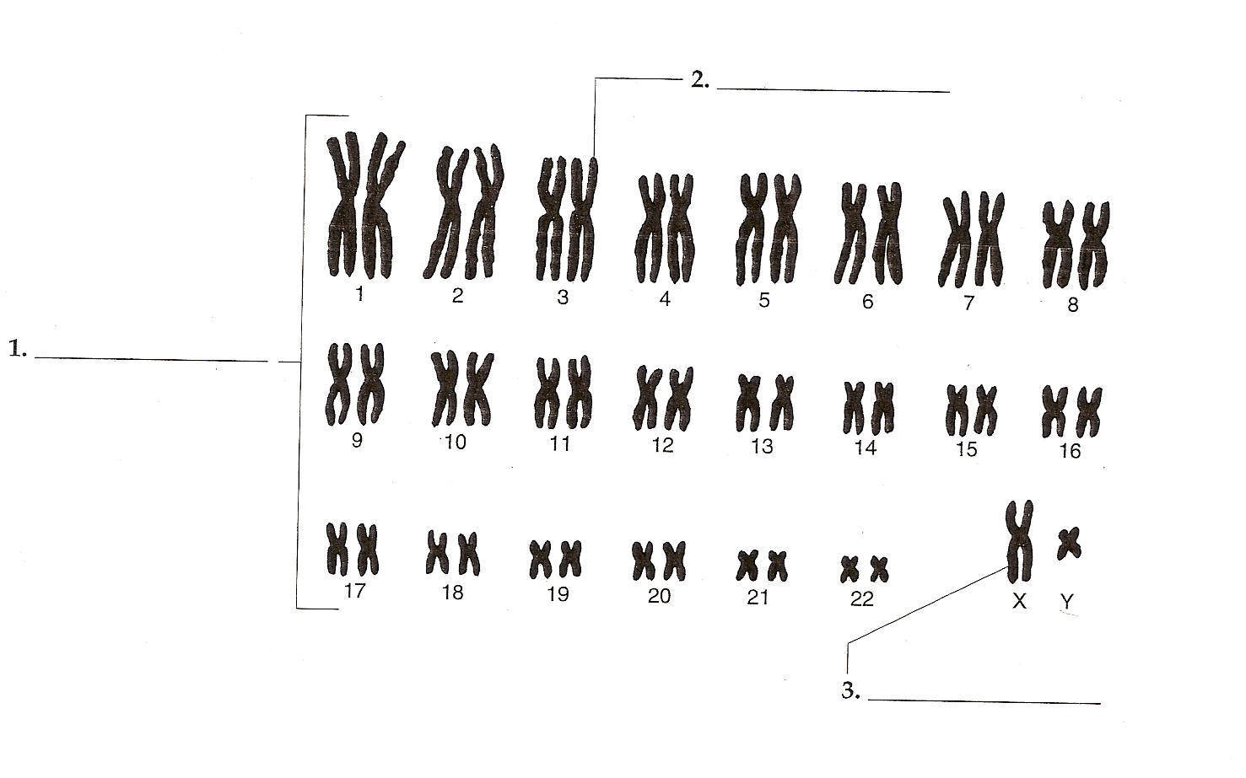
Autosome
Karyotype
Sex Chromosome
J. Matching: In the space provided, write the letter of the definition that best matches each term.

- karyotype e. pedigree
- sex chromosome f. sex-linked gene
- autosome g. nondisjunction
- DNA fingerprinting

e 27. chart that shows the relationships within a family
g 28. failure of homologous chromosomes to separate in meiosis
_____a_____29. picture of chromosomes arranged in pairs
_____d_____30. test used to identify individuals by analyzing sections of DNA
_____b_____31. chromosomes that determine an individual’s sex
_____f_____32. gene located on the X or Y chromosome
_____c_____33. chromosomes that do not determine sex

K. Cloning: Answer the questions in complete sentences.

- What is a clone? A clone is a member of a population of genetically identical cells produced from a single cell.

- What kinds of mammals have been cloned in recent years? Sheep, cows, pigs, mice, and other mammals have been cloned.

L. Complete the sentences in the diagram below to show the steps involved in cloning a sheep.
- cell c. nucleus
- divide d. embryo

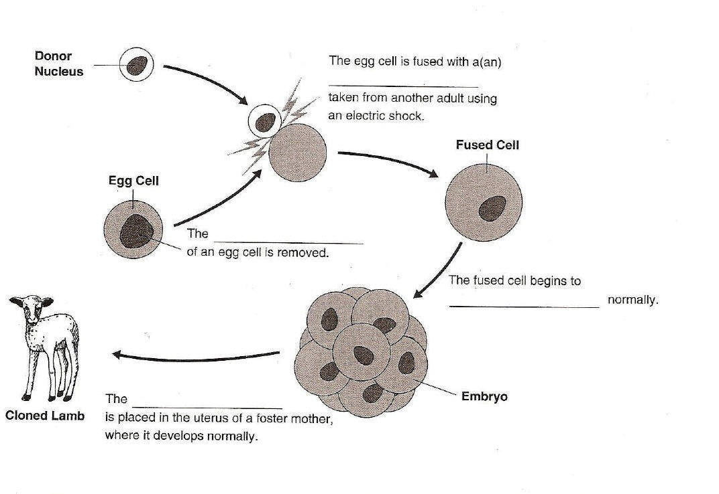
Cell
Nucleus
Divide
Embryo
M. Gel Electrophoresis: Answer the following questions as they relate to genetic engineering.

- What is genetic engineering? Genetic engineering is making changes in the DNA code of a living organism.

- Is the following sentence true or false? Making changes to the DNA code is similar to changing the code of a computer program. True

- Scientists use their knowledge of the (structure) of DNA and its (chemical) properties to study and change DNA molecules.

- List four steps that molecular biologists use to study and change DNA molecules.
- Cut DNA into smaller pieces
- Identify the sequence of bases in a DNA molecule
- Extract DNA from cells
- Make unlimited copies of DNA
  - _____3_____
  - ____ 1 _____
  - ____ 2__ ___
  - ____4_ ____

- Explain how biologists get DNA out of a cell. The cells are opened, and the DNA is separated from the other cell parts.
- Biologist use (restriction enzymes) to cut DNA molecules at a specific sequence of nucleotides to make smaller fragments.

- Circle the letter of the process by which DNA fragments are separated and analyzed.

  - gel electrophoresis c. transformation
  - extraction d. restriction

- In diagram below label the positive and negative ends of the gel and identify the location of longer and shorter fragments.

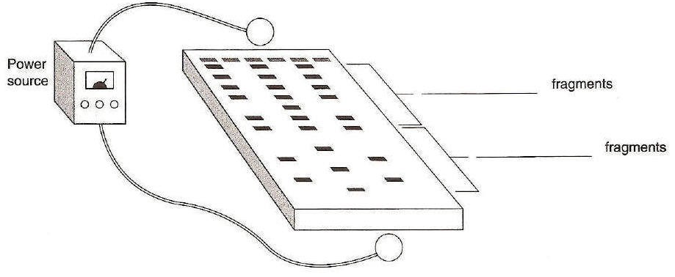
Longer
Shorter

N. Flowchart/Order: Complete the flowchart for DNA replication by arranging the events listed below in the order they occur. Use information from the textbook.

- DNA polymerase joins individuals nucleotides to produce a new strand.
- DNA molecule “unzips” and the two strands unwind.
- DNA polymerase proofreads the new strands.
- Unwound strands of DNA serve as templates for new DNA.

1
DNA molecule “unzips” and the two strands unwind.

2
3
4
Unwound strands of DNA serve as templates for new DNA.
DNA polymerase joins individual nucleotides to produce a new strand.
DNA polymerase proofreads the new strands.

O. DNA Fingerprinting: Using the data taken from the crime scene, analyze the DNA
sequence for each case and answer the questions.
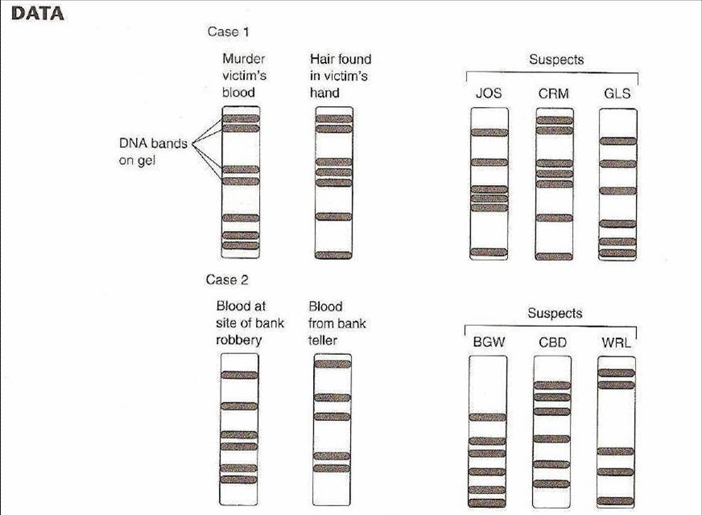

- For case 1, compare the DNA fingerprint patterns of the suspects with patterns
from suspects and patterns from samples at the scene of the crime. Do any of
the patterns match? Name any matching patterns.
In case 1, the pattern of the hair found in the victim’s hand matches the pattern
of CRM.

- Based on the evidence, were any of the suspects involved in the murder?
Explain your reasoning.
The criminal is suspect CRM because the pattern of the hair found in the victim
pattern of the hair found in the victim’s hand matches the pattern of CRM.

- For case 2, compare the DNA fingerprint patterns of the suspects with patterns
from samples at the scene of the crime. Do any of the patterns match? Name
any matching patterns. There are no matching patterns in case 2.

- Based on the evidence, were any of the suspects involved in the bank robbery?
Explain your reasoning. No suspects were involved in the bank robbery because
there is no suspect pattern that matches a pattern from the crime scene.

- Do you think that DNA fingerprinting is totally reliable? Explain why or why
not? The answers are a matter of opinion. The effect of probes should be a part
of the answer.

