.

SCIENTIFIC METHOD UNIT

- _ _________________ is the study of life.
- List the steps of the scientific method.
  - What is a hypothesis?
- What is a theory?
- What is a dependent variable? What is an independent variable?
- What is a control?
- List the characteristics of life.
- Define homeostasis.
- Review your safety procedures.
- List the steps for using a compound light microscope. What would one be used for? How is total magnification calculated?

Directions: The following are experimental scenarios. Read the experiments and then identify the components of the scientific method.

Experimental Scenario #1
A student investigated whether ants dig more tunnels in the light or in the dark. She thought that ants used the filtered light that penetrated the upper layers of earth and would dig more tunnels during the daytime. Ten ant colonies were set up in commercial ant farms with the same number and type of ants per ant farm. The same amount of food was given to each colony, and the colonies were in the same temperature. Five of the colonies were exposed to normal room light and five were covered with black construction paper so they did not receive light. Every other day for three weeks the length of the tunnels was measured in millimeter using a string and a ruler. Averages for the light and dark groups for each measured were then computed. The averages are listed in the following chart.

Length of Tunnels (mm) Constructed by Ants in Different Light Conditions
Day Light Dark
1 5 7
3 10 15
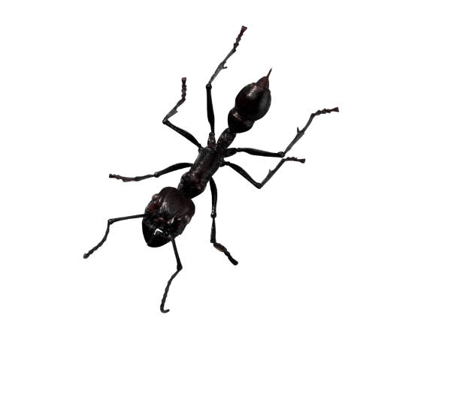
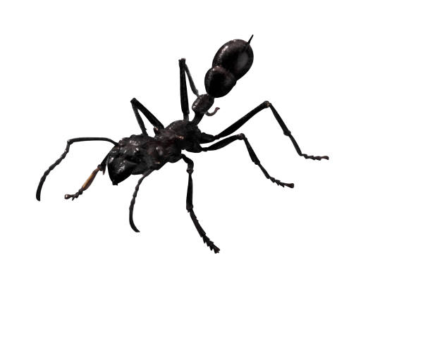
5 20 25
7 26 32
9 32 47
11 50 62
13 61 93
15 66 110
17 90 115
19 95 120
21 103 136
IV:
DV:
Control Group:
3 Constants:
Conclusion:
2 Improvements:

Experimental Scenario #2
A student investigated the effect of radiation on the germination of bean seeds. He thought that exposure to radiation would limit the seeds ability to germinate (grow) much like ultra-violet light causing skin cancer. Three hundred seeds were soaked in distilled water for one hour. They were then divided into three groups. One group was placed in a microwave oven on high for three seconds. Another group was microwaved on high for six seconds. The last group was not microwaved. The seeds were then planted in three separate flats and given the same amount of water. The seeds were then planted in three separate flats and given the same amount of water. The flats were placed in a location with a constant temperature of approximately 27 degrees Celsius. Each day for two weeks the number of seeds that germinated each group was recorded.

Total Number of Bean Seeds Germinated after Microwave Radiation
Three Seconds of Radiation Six Seconds of Radiation No Radiation
54 26 88
IV:
DV:
Control Group:
3 Constants:
Conclusion:
2 Improvements:

Experimental Scenario #3
A student investigated the effect of aged-grass compost (fertilizer made from decaying plant material) on the growth of bean plants. She thought that the compost would provide extra nutrients and make plants grow faster. Thirty bean seeds were divided into three groups and planted in different flats (boxes). All seeds germinated after 12 days and were allowed to grow for five days. The flats were ach given the same amount of water and the same amount of light. Flat A was then fertilized with 3-month old compost; Flat B was given 6-month old compost; and Flat C was given no compost. At the end of 14 days the height of each plant was measured in centimeters.

IV:
DV:
Control Group:
3 Constants:
Conclusion:
2 Improvements:

BIOCHEMISTRY UNIT

- Review the properties of water.
  - Why does ice float on the top of liquid water?
  - _________________ is the most abundant compound in living things.

- What makes up a solution? Define its components.

- Complete the following chart on the pH scale.
 | pH range | H+ concentration is higher or lower than pure water
Acid
Neutral
Base

- Complete the chart below:
Carbon Compound | Function/Job | Subunit (Monomer)
Carbohydrate
Protein
Lipid
Nucleic Acids
- What is a chemical reaction?
  - In the following equation, label the products and reactants:
6CO₂ + 6H₂0 → C₆H₁₂O₆ + 6H₂0

- Define activation energy.

- What is a catalyst? How are enzymes different than catalysts?

- Label the products, enzyme, substrate, and active site on the picture below.
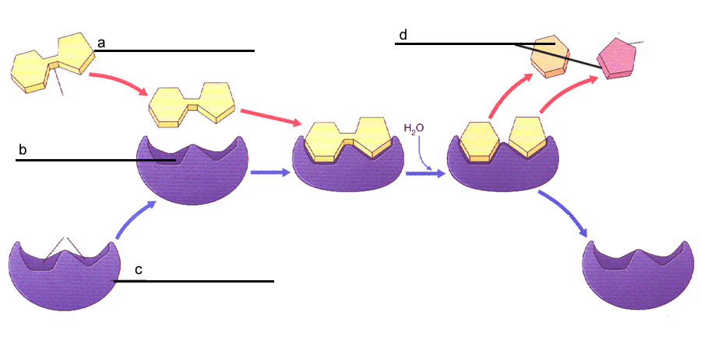
- What happens when you change the shape of an enzyme?
  - What factors will cause the shape of the substrate to change (affect the rate that an enzyme works)?
Answer true or false to the following statements:
a. _______ Enzymes interact with specific substrates
b. _______ Enzymes change shape after a reaction occurs
c. _______ Enzymes speed up reactions.
d. _______ One enzyme can be used for many different types of chemical reactions.
e. _______ Enzyme reactions can be slowed or halted using inhibitors.
CELL UNIT
- List the three parts of cell theory.
- Review your cell organelles!!!
_____ Prokaryotic cell  _____ Eukaryotic cell  _____ Cell membrane  _____ Cell wall  _____ ER  _____ Nucleus  _____ Nucleolus  _____ Ribosome  _____ Golgi Apparatus  _____ Lysosomes  _____ Mitochondria  _____ Chloroplast  _____ Vacuole  _____ Cytoskeleton | A. builds proteins  B. transport system for the cell  C. the “power house” of the cell, makes ATP  D. makes “food” for the cells  E. finishes, packages, and ships proteins  F. disposes of waste for the cell  G. no nucleus, contains ribosomes, mainly unicellular  H. protects DNA, controls the cell  I. contain distinct organelles, mainly multicellular  J. produces material used to make ribosomes  K. made of microtubules and microfilaments, helps support the cell and movement within the cell  L. storage for water  M. regulates the traffic entering or leaving the cell  N. provides structure to the cell, made of cellulose in plants/algae
- Define prokaryote and give an example.
- Define eukaryote and give an example.
- What is cell specialization?
- List the levels of cellular complexity in multicellular organisms.
Cell- ______________-______________- ______________- Organism

