Name _________________________________________ Date __________________ Class ______ Blue
 Genetics Test 

1. Label the pictures using the following words: DNA, RNA, bases, backbone, replication
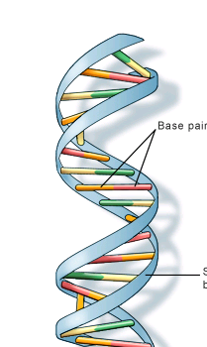
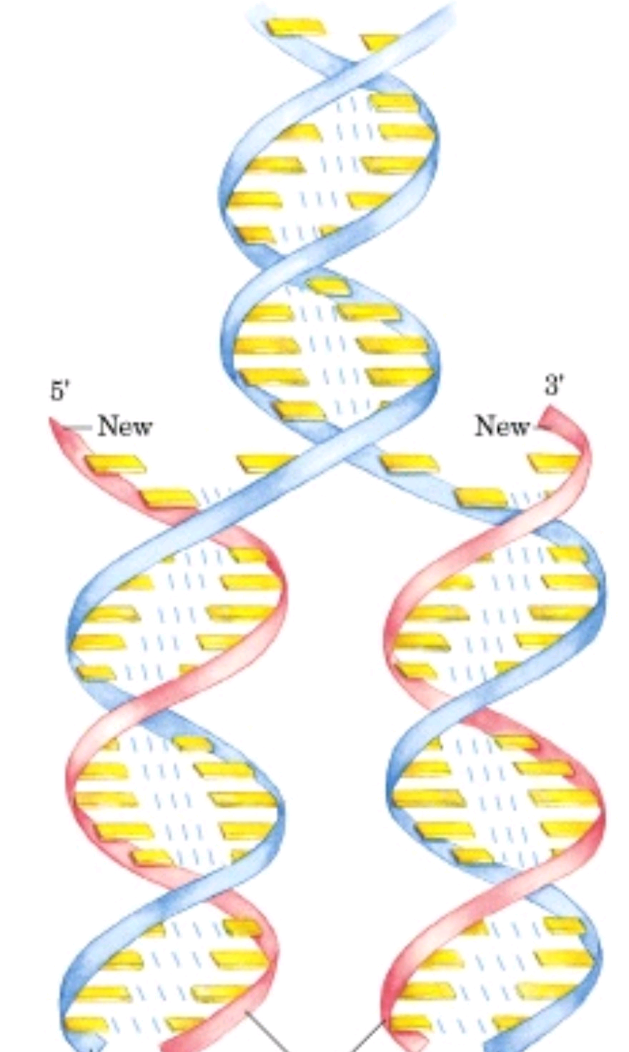
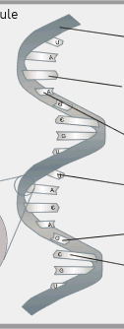

2. The backbone is made up of
A) nitrogen B) oxygen C) sugar and phosphate D) nitrogen and phosphate

3. What are the 4 bases in DNA? _____, _____, _____ and _____
How do the bases pair? _____ with _____ and _____ with _____

4. Fill in the chart below
 | DNA | RNA
# of strands
Sugar (Deoxyribose or Ribose)
Bases used

5. Label the parts of the diagram about protein synthesis:
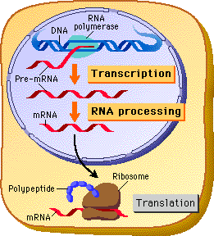
Word Bank
DNA
RNA
Protein
Translation
Transcription
Ribosome
(Hint: RNA → protein)
(Hint: DNA → RNA)

6. State which amino acid each RNA codon codes for:
AUG = _____________________ UCG = ______________________ CAG = ______________________
GCA = _____________________ CCA = ______________________ UUG = ______________________
ACG = _____________________ UAG = ______________________ UCA = ______________________
GCG = _____________________ CUA = ______________________ ACU = ______________________
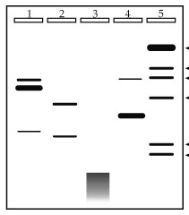
7. Label the pictures: cloning, gel electrophoresis, recombinant DNA
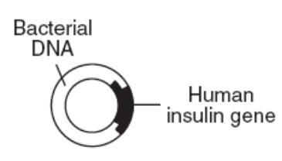
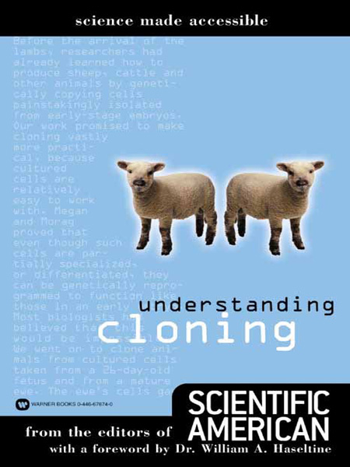

__________________________ ____________________________ _______________________

8. Fill in the Punnett Squares and answer the questions.
Mother: blue eyes (bb) Mother: tall (Tt)
Father: brown eyes (Bb) Father: tall (Tt)

______ % of the offspring will have brown eyes ______ % of the offspring will be tall
______ % of the offspring will have blue eyes ______ % of the offspring will be short

9. Define the following words:
Replication: _____________________________________________________________________________
Mutation: _______________________________________________________________________________
Double Helix: ___________________________________________________________________________

10. Proteins are made up of
A) deoxyribose and phosphate B) amino acids C) nucleotides D) bases

11. DNA and RNA are made up of
A) deoxyribose and phosphate B) amino acids C) nucleotides D) bases

12.
Explain how you know the DNA came from 4 different people.
_______________________________________________________________________________________________________________________________________________________________
________________________________________________________________________________________________
__________________________________________________________________
__________________________________________________________________

Name _____________________________________ Date _______________ Class ______ Green

 Genetics Test 
1. Fill in the blanks with the following words:
tRNA amino acids
radiation restriction enzymes
nucleus ribosomes
double helix mutation

a) The DNA is located in the ______________________.
b) Proteins are made up of _______________________.
c) ____________ carries an amino acid.
d) ______________________ make proteins.
e) A ____________________ is a change in DNA.
f) ____________________________ cut DNA.
g) The shape of DNA is called the ______________________________.
h) One thing that can cause mutations is ______________________________.

2. Explain the process of protein synthesis by filling in the blanks:

____ ____ ____ ____ ____ ____ _____________________

3. How is DNA different from RNA?
a) _____________________________________________________________________________________
b) _____________________________________________________________________________________
c) _____________________________________________________________________________________

4. Draw OR describe the 3 basic steps of DNA replication below:

________________________ ________________________ _____________________________
________________________ ________________________ _____________________________
________________________ ________________________ _____________________________
________________________ ________________________ _____________________________
5. Label each diagram.

__________________________ ____________________________ _______________________
6. Label the diagram below:
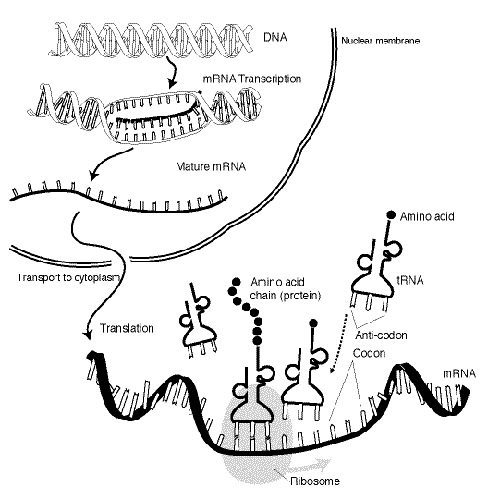
1
4
5
9

7
8
2
6
Word Bank
amino acid
base
mRNA
protein
ribosome
tRNA
transcription
translation

7. State which amino acid each RNA codon codes for:
AUC = _____________________ UCG = ______________________ AAG = ______________________
GCA = _____________________ CGA = ______________________ UCG = ______________________
AGG = _____________________ UAC = ______________________ UCA = ______________________
GUG = _____________________ CUG = ______________________ AUG = ______________________

8. Which process is illustrated in the diagram below?
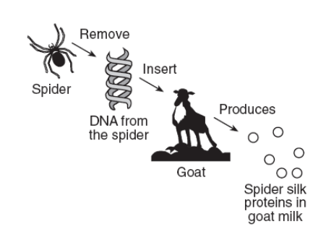
(1) chromatography
(2) direct harvesting
(3) meiosis
(4) genetic engineering

Name ____________________________________ Date _________________ Class ______ Orange
 Genetics Test 

1. Label the picture below.
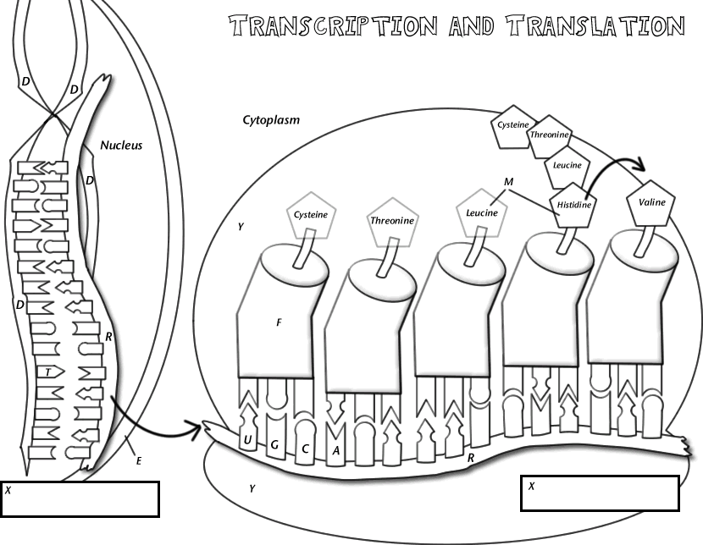

Transcription occurs in the _____________________________. Translation occurs in the ________________________.

2. Draw a picture of replication below.

3. Fill in the blanks.
a) The DNA is located in the ______________________.
b) Proteins are made up of _______________________.
c) _________ carries an amino acid.
d) DNA is made of subunits called ________________________.
e) ______________________ make proteins.
f) A ____________________ is a change in DNA.
g) ____________________________ cut DNA.
h) The shape of DNA is called the ______________________________.
i) One thing that can cause mutations is ______________________________.

4. What is cloning? ________________________________________________________________________
________________________________________________________________________________________
Do clones ever occur naturally in nature? _________ If so, give an example. ________________________

5. a) Using the information given, fill in the missing mRNA base sequence for Species B in the chart below.
b) Using the amino acid table, fill in the missing amino acid sequence for Species C in the chart below.
c) According to the amino acid sequences, which two species are most closely related?
__________________ and
__________________

Explain why. ______________________________
__________________________________________________________________________________________
____________________________________________________________
_____________________________________
_____________________________________
_____________________________________
_____________________________________

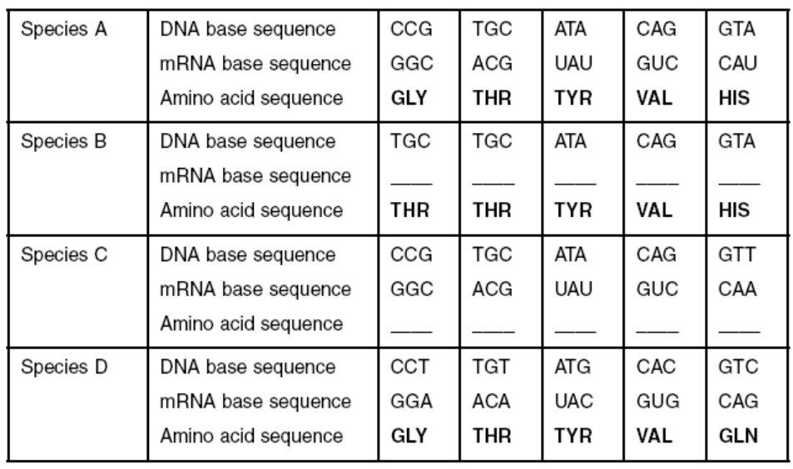

6. Three structures are represented in the diagram below.
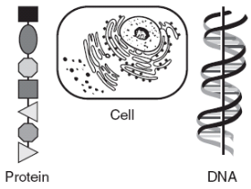
What is the relationship between these three structures?
(1) DNA is made up of proteins that are synthesized in the cell.
(2) Protein is composed of DNA that is stored in the cell.
(3) DNA controls the production of protein in the cell.
(4) The cell is composed only of DNA and protein.

7. A product of genetic engineering technology is represented below.
Which substance was needed to join the insulin gene to the bacterial DNA as shown?
(1) a specific carbohydrate
(2) a specific enzyme
(3) hormones
(4) antibodies

Use the diagram below to answer questions 8-11.

The four wells represented in the diagram were each injected with fragments that were prepared from DNA samples using identical techniques.
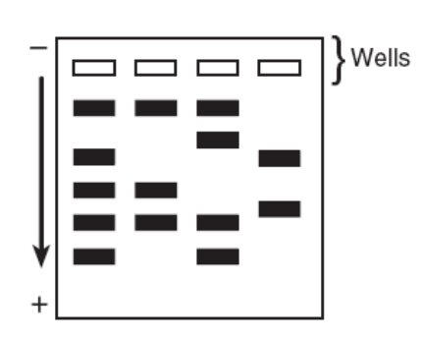
8. This laboratory procedure is known as
(1) cloning
(2) gel electrophoresis
(3) chromatography
(4) use of a dichotomous key

9. The arrow represents the direction of the movement of the DNA fragments. What is responsible for the movement of the DNA in this process? _________________________________________________

10. The four samples of DNA were taken from four different individuals. Explain how this
is evident from the results shown in the diagram.
__________________________________________________________________________________________
__________________________________________________________________________________________
__________________________________________________________________________________________

11. Identify the substance that was used to treat the DNA to produce the fragments that
were put into the wells. ______________________________________________________________________________________

12. How is DNA different from RNA?
a) _____________________________________________________________________________________
b) _____________________________________________________________________________________
c) _____________________________________________________________________________________

13. What is a mutation? _____________________________________________________________________

14. The diagram below represents a section of a molecule that carries genetic information.
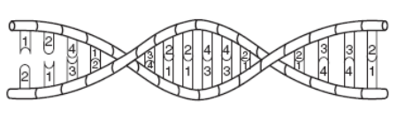
The pattern of numbers represents
(1) a sequence of paired bases
(2) the order of proteins in a gene
(3) folds of an amino acid
(4) positions of gene mutations

Use the diagram below to answer questions 15-17.

In DNA, a sequence of three bases is a code for the placement of a certain amino acid in a protein chain. The table below shows some amino acids with their abbreviations and DNA codes.
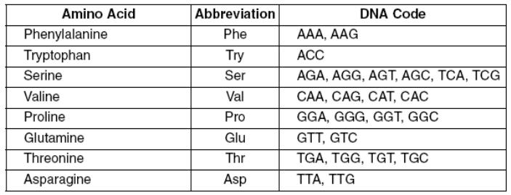

15. Which amino acid chain would be produced by the DNA base sequence below?
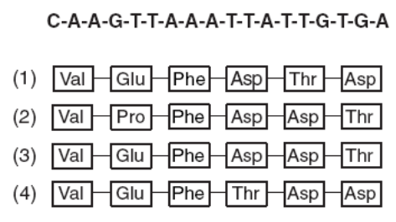

16. Identify one environmental factor that could cause a base sequence in DNA to be changed to a different base sequence. ______________________________________________________________

17. Describe how a protein would be changed if a base sequence mutates from GGA to TGA.
________________________________________________________________________________________________________________________________________________________________________________________________________________________________________________________________________________________________________________________________________________________________________

